INTRUSION AND HARASSMENT

Being in the public eye means ITN often attract a lot of attention from members of the public. Sometimes this attention can become intrusive and in some cases border on harassment.

The internet, Twitter and social media offer members of the public a new way of interacting with news presenters and reporters. Most individuals simply want to engage with their favourite journalist and are harmless. But sometimes they can take it too far.

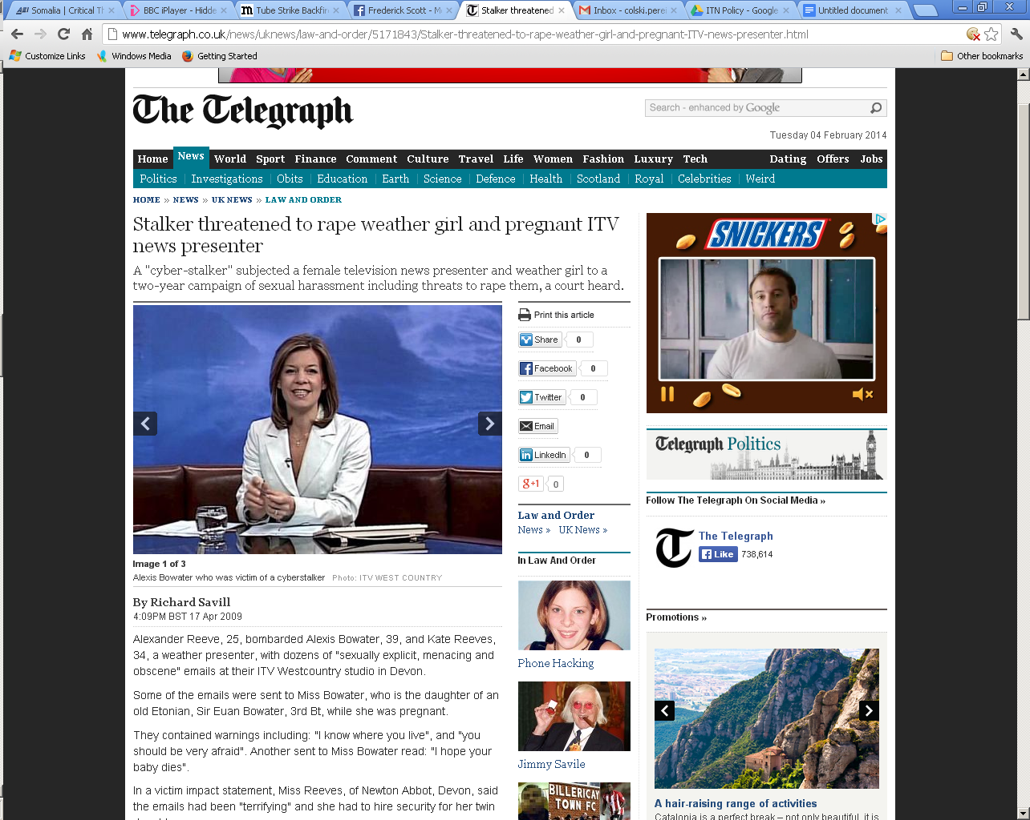

Individuals can develop an unnatural fixation on on-screen talent. Most often people are just looking for help or are seeking an intimate relationship, but occasionally they can become aggressive.

Behaviour that is intrusive, unwanted, and repetitive leading to anxiety or distress - constitutes harassment and if persistent, then stalking.

Staff often accept this kind of behaviour as an occupational hazard or because they do not want to cause a fuss. However, this behaviour is illegal under the Harassment Act 1997.

ITN is committed to ensuring the well being and safety of all staff members. If you are being exposed to such attention, there are steps that can be taken and assistance on hand.

Individuals also have a responsibility to consider their own behaviour, particularly with regards to social media.
- Revealing intimate details or pictures will frequently result in unwanted attention.
- Geo-tagging pictures or announcing where you will be in advance – can be dangerous. Do not do this.
- Also consider your total internet footprint. If you use multiple social media platforms, you may inadvertently reveal more about yourself than you intend. For example, if you tweet the rough area where you live and then geo-tag your favourite haunts or street in Instagram – fixated individuals can narrow down your abode.
- Do not respond to random individuals in an over familiar fashion, reveal personal details about yourself or respond during out of office hours. Such actions may be misinterpreted.
- It is sensible not to leave your mobile number on your landline voicemail message or on your email out of office.
- Also if concerned, remove yourself from 192 and ask for anonymity on the electoral role.

Common forms of intrusion

Behaviours associated with harassment or stalking are:

- Sending or leaving unsolicited materials/gifts
- Ordering or cancelling goods and services for victim
- Making vexation complaints
- Appealing for help with strange issues
- Persistent tweeting or emailing
- Threats or sexual suggestions
- Physically appearing at victims workplace, social haunts or house
- Property damage
- Violence

Sometimes the individuals do not realise they are intruding, but sometimes they have malicious intent.

The Four Golden Rules

If you are exposed to any of the behaviours above then it is advised to do the following:

- Have NO contact with the intrusive individual
- Tell ITN management, Head of Security and your family
- Increase situational awareness and vigilance
- Collect Evidence

Following these steps and working with ITN security will improve the chances of a successful intervention and to keep safe.

No Contact

Ideally, do not ever respond or contact an individual exhibiting the behaviours associated with stalking.

In the modern media age this is easier said than done. It is frequent that staff will enter a twitter conversation or email exchange with a member of the public before realising something is a wry.

However the moment you feel uncomfortable, you should cease contact.

Contact of any sort merely encourages the individual to continue. Private/personal thoughts that are communicated can be misinterpreted as an encouragement to further communication.

The police / or ITN Management should be the only ones to confront the offender.

Tell ITN Management and your family

Telling your ITN manager and your family can reduce the possibility of others inadvertently providing information to the intrusive individual.
Don’t let unwanted attention carry on without taking action to stop it. If in any doubt, refer.

Alert them to the significance of any event they witness.

Help provide stronger evidence should the case go to court.

Provide the victim with psychological support

Looking after your safety

It is important you take responsibility for your safety and not ignore the problem – even if it is scary.

Always carry a mobile phone with you in case you need to call for assistance.

Work with the ITN Head of Security to improve protection in the home and of personal information available online.

Check 192 or the electoral role to make sure your address is not available online. Double check your internet profile.

Consider the safety of your loved ones and friends.

Contacting the police for advice. The police may issue a warning and/or can prosecute for stalking and harassment. There are also court orders that can be applied for to stop unwanted communication.

Collecting Evidence

Evidence is crucial in preparing a case against an intrusive individual. Keep all correspondence and document everything.

Keep a journal/log that is a chronological summary of events.

Save everything.
- All paper communications and envelopes
- Emails should be stored in a folder and backed up on a drive
- Tapes from answering machines or voice mails on phone
- Texts should be saved and downloaded on a drive
- Tweet URLs should be saved and screen grabs taken
- Do not destroy, delete or throw out any communications, messages or gifts. Deleting evidence makes the police job much harder. Do not rely on others to save things.

Actions in the case of suspicious or malicious communications

It is not uncommon for suspicious or malicious mail to be delivered to ITN or unpleasant phone calls to be received.

If you are the recipient of such communication or correspondence, please do the following:

- Record the details of the caller / correspondence. Take a photo on your smart phone or a photocopy.

- If the communication contains a serious or imminent threat, immediately inform the ITN Head of Security and your business area’s line management.

- If there is no threat, but the correspondence is concerning place the letter in a plastic envelope/folder and send through internal mail to the head of security. Also send through the envelope.

- Things to look out for in any correspondence are:

  - Direct threats or suggestions of violence
  - End of tether language (i.e. you are my only hope / last resort)
  - Personalised quests for justice
  - Prolific letter writing/calling / Scrawled hand writing
  - Bizarre content
  - Delusional content (i.e. the voices tell me / mentions of torture/rape)
  - Erotomanic thoughts – author has amorous or sexual thoughts

- Do not over handle the letter. And do not show it to others and let them handle it. Depending on the nature of the letter, finger prints off the letter maybe required.

- Do not pass on gifts from members of the public to presenters / reporters / on screen talent. Inform the Head of Security.

- If the individual sending the correspondence or calling does this frequently, inform the Head of Security.

An unwanted visitor has come to the building

It is rare, but occasionally unwanted visitors come to ITN premises asking to see presenters, reporters and on screen talent. The reception will phone through to the News Desks.

If this occurs you should follow this protocol:

- Establish whether the visitor is genuine or not. Find out who the individual is via the reception, if the person he/she wants to visit knows them and the mood of the individual.

- If the individual is unwanted, inform the reception that the person should not be admitted to the building and the police called / Head of Security to be informed.

- Ask the reception to inform you when the person has vacated the building.

- Tell others in the Newsroom, particularly the on screen talent. It is sensible not to let on screen talent enter the reception area while the person is in the building. They should use the rear entrance of the building.

- Inform other Newsrooms in the building, so that their on screen talent does not enter the reception.

Twitter Victim Advice / Trolling

If you receive an abusive message -
- Take a screenshot so that you have physical evidence. Also get the URL of the Tweet as Twitter requires this.
- Do not feed the troll
There is nothing trolls fear more than being ignored. Don’t engage with them in any way – not even to tell them you are reporting them.
- Block the troll
You can find instructions on how to do that here:
http://support.twitter.com/entries/117063
- Report the troll as abusive
https://support.twitter.com/forms/abusiveuser
NB – You or your authorised representative can do this e.g. your agent. They might need to provide evidence of this the first time.
- If appropriate, report the troll as spam
If the same troll is sending out the same tweets to several people, then report them as spam. You can find out how to do that here:
http://support.twitter.com/articles/64986-how-to-report-spam-on-twitter
- Keep the response from Twitter safe
Once you’ve reported the troll, you should get an automated response from Twitter with a ticket number. If you don’t get one, check your spam folders etc. – make sure you’ve got it for future reference.
- Inform your management and the Head of Security. If necessary, do inform the Police.
If you feel the abuse you’ve received has been threatening, then do go ahead and report it to the Police.
- To make abuse feel less intrusive
You can change your Twitter settings so that you miss a lot of abusive content. Set up your Twitter notifications so that you only receive notifications from people you follow. The method for doing this will change depending upon how you get your notifications:
for email: https://twitter.com/settings/notifications
for SMS: https://twitter.com/settings/devices
in the mobile app: settings > accounts > [account] > notifications

Support agencies

National Stalking Helpline
http://www.stalkinghelpline.org/
0808 802 0300

Suzy Lamplugh Trust
http://www.suzylamplugh.org/
Ph: 020 7091 0014

